**MIDDLE EAST TECHNICAL UNIVERSITY**

**DEPARTMENT OF ELECTRICAL & ELECTRONICS ENGINEERING**





**TROY TECH**

**CRITICAL DESIGN REVIEW REPORT**

**Section:** 7

**Studio Coordinator:** Mustafa Mert ANKARALI

**Partners:**

Hasan ÖZKARA - 2031888

Kağan ÖZASLAN - 2031854

Caner POTUR - 2031250

Mustafa Ercan OKATAN - 2031193

Mert KAYIŞ - 2030997

**Table of Contents**

**1. Executive Summary .........................................................................................................3**

**2. Introduction ......................................................................................................................4**

**3. System and Subsystem Descriptions.............................................................................5**

**4.** **System and Subsystem Level Technical Specifications.............................................8**

**4.1. Technical Specifications of Video Transfer Subsystem......................................... .8**

**4.2. Technical Specifications of Command Transmission Subsystem.... ...................12**

**4.3. Technical Specifications of Motor Drive Subsystem............................................. 18**

**4.4. Technical Specifications of Shooting Subsystem.............................. ...................22**

**4.5 Technical Specifications of Power Supply Subsystem.............................. ............24**

**5. System and Subsystem Modifications with Justifications ..................................... 25**

**6. Compatibility of Subsystems..................................................................................... 27**

**7. Design Requirements..................................................................................................29**

**8. Test Results and Future Test Plans ......................................................................... 30**

**9. Cost Breakdown and Analysis, Power Distribution..................................................31**

**10. Conclusion ................................................................................................................ 32**

**Appendix...........................................................................................................................33**

**1.Executive Summary**

Nowadays, robotic solutions for innovative technological products include both tele-operation and autonomous actions. As Troy Tech, we are mainly focusing on the tele-operation side and developing new solutions for wireless operations. We aim both financial efficiency and reliable operation in our project. Integration of different systems sometimes become problematic, but we are trying to predict possible difficulties and gather all the parts together in a compatible way.

Our ongoing project requires a robot playing hockey in a hexagonal playfield. It is supposed to be controlled from at least 30-meters for indoor usage. Tele-operation will be done by just looking at a screen showing the live broadcast. The video recorded by the camera that is located on the robot will instantly transferred to the controller room.

Our teleoperated robot, Helen-V consists of five main subsystems which are video transmission, command transmission, motor control, shooting mechanism and power supply. We gave priority to solve the problem of transferring the live video data with minimum latency from the robot to the controlling side. After doing some research on this problem, we ordered a 600mw 5.8 GHz transmitter and ROTG02 as a 5.8Ghz FPV receiver with a FPV camera for this part and did some tests and quality controls. At the beginning, our camera unit was integrated with the video-transmitting antenna. Then we replaced it by a transmitter with higher power and externally connected camera. This replacement enhanced the distance that video signal reaches both indoor and outdoor areas. At this point, we prefer using a power amplifier giving 2.5 W output power in order to have a video transmission without interruption. The second sub-system is the command transfer where we used digital data transfer from the controlling side to the robot. This sub-system includes an Arduino uno and an Arduino mega connected to NRF24L01 transceivers. We replaced their antennas with larger ones with higher gain in order to increase the communication range. We uses a playstation 1 joystick and NRF24L01 transmitter connected to Arduino uno to give command to motors and shooting solenoid which is on the HELEN-V. The other part consists of three DC motors and two motor driver. These motors connected to three omni-wheels takes controlling data from the Arduino uno connected to the receiver NRF24L01. The last operational sub-system includes the mechanism to shoot the ball into the opponent’s goal. For this purpose, we prefer using a push and pull solenoid with 34 mm stroke length. We increase the 12V source voltage to 35V by the help of the DC-DC up converter and we give energy to the solenoid through a 2200 uF capacitor. This part is also controlled by the digital signal coming from the command transfer system. Finally, we have a power supply system which consists of a 12V accumulator and two power banks. By the help of the power banks, we get 5V DC to energize the arduino mega and camera and the accumulator is for motors and the solenoids. Additionally we have one more power banks at the controller room.

Although this project has many challenging aspects like the wireless data transfer to 30- meters and shooting mechanism , our group members-built consensus on this project involves much fun and the final product will satisfy our engineering enthusiasm.

Actually, as Troy Tech Co. our main concern is to produce a perfectly working robot in a short period. We estimates to complete the HELEN-V until the April with the cost of $160.

**2. Introduction**

Our company, Troy Tech is interested in creating new approaches in robotic systems and specially tele-operated robots. In the project called “Devices trying to score in each other’s goals”, we aimed to design and construct a robot that scores in opponent robots goal. The robot will not be self-operated or autonomous, an operator will control the movements on the floor and also the shooting of the ball. By doing the robot easily and accurately controllable by an operator (player) at a distance wirelessly, we aimed at accomplishing entertainment purposes of the game.

This project had several challenging ways such as the transfer of the video data and commands wirelessly at least 30 meters in closed area. Another problem was to build a robust controlled device in a small playfield and it was expected that it moves smoothly and time-invariant. For the purpose of meeting these requirements and challenges, we also had enhanced design solutions that are feasible and reliable.These solution approaches were also planned efficient in terms of both budget and time. We are aware of the fact that the most important cost is ‘time’ in all engineering applications. We are proceeding carefully on track of the project to fit the time schedule of the project as planned.

In this ‘Critical Design Review Report’, we will explain the design of our overall system including every technical detail. Improvements and modifications done after the Conceptual Design Report are also included in the following parts of this report. We were supposed to resolve the essential system top-level design. Since we will not be able to change the critical parts after this report in the remaining time before the end of semester, the results of our application tests and plans are also discussed in this report with sufficient details. In other words, we have finalized all the solutions that we have come up with in the previous phases and reports of this project. Here, we should state that we took the advantage of constructing a reliable design steps and finding out different alternative solutions in the previous parts.

**3. System and Subsystems Description**

**3.1 Overall Description**

Our project consists of four main subsystem; analog video transfer, command transfer, motor drive and shooting mechanism. The analog transfer subsystem is separated while other parts are jointed.

We used a FPV video camera for monitoring the game field and we prefered TS5828 transmitter in order to transmit the signal coming from the video camera. Then, we received the signal by the Rotg02 receiver module and transferred the video to a screen (android smartphone or pc) for monitoring the video of the game field. The whole process forms our analog video transfer subsystem.

Moreover, we have a command transfer subsystem which consist of a controller, an arduino microcontroller and two NRF24 transceiver (one for receiver, another one for transmitter) successively. Also we have one more arduino microcontroller connected to the receiver NRF24. Finally we have a L298N dual motor drive and motors connected successively, which forms motor drive subsystem, and we have shooting mechanism connected to the arduino. The overall block diagram can be seen in Fig 1.

*Figure 1. Overall block diagram of the project.*

**3.2. System level flowchart**

*Figure 2. Flowchart of video transmission system*



*Figure 3. Flowchart of command transmission and motor drive systems*

**3.3.Description of Subsystems**

**i) Analog Video Transfer Subsystem**

We were asked for providing wireless video transfer for at least 30m distance indoor. We used a fpv video camera and transmitter-receiver pair in order to transfer the video which is recorded by the video camera. The frequency of the transmitted signal is 5.8GHz (we are able to select the channel between 5.6GHz and 5.9GHz.) while its power is 600mW. Also, we are using a 5.8g signal amplifier in order to get 32dbi.

**ii) Command Transfer Subsystem**

Like in video transfer, we are asked for transfering command information for at least 30m distance indoor. We use a ps1 joystick in order to give appropriate command information. Then, we used a NRF24L01 transceiver module in order to transmit the information coming from the joystick. In order to receive the incident signal we used one more NRF24 transceiver as receiver on the robot. The operating frequency of the NRF24 transceiver is 2.4 GHz.

**iii) Motor Drive Subsystem**

We used 3 DC motors and 3 omni-wheels for the movements of our robot on the floor. This subsystem is responsible for all the rotating and linear movements that aims to shoot the ball and also defense the goal. In order to provide each motor with enough amount of current, we made use of motor-driving integrated circuit L298N which includes power transistors inside.

**iv) Shooting Subsystem**

The shooting mechanism is also an essential part of our project. We are using a push-pull solenoid to shoot the ball. We get 35 V (from the DC-DC converter) for the solenoid in order to have powerful shooting. Basically, it pushes the metal block when it gets 35 V and it returns its initial position after stopping energy.

**4. System and Subsystem Level Technical Specifications**

**4.1 Motor Drive Subsystem**

**4.1.1 Motors**

We chose Namiki 22CL-3501PG with encoder for our motor drive subsystem as shown in Fig.10. Its specifications are given in Table 1.



*Figure 4. Namiki 22CL-3501PG with encoder*

*Table 1. specifications of Namiki 22CL-3501PG*

|  |  |
| --- | --- |
| Type | Gear Motor |
| Voltage | 12V |
| Stall Torque: | 1.6Nm (16Kg · cm) |
| Continuous torque | 0.5Nm |
| Output speed: | 120 r / min |
| Encoder: | 2 pulses per revolution |

**4.1.2 Encoder**

Motor Drive Subsystem can be constructed as an open loop system or closed loop system as shown in Fig. 11. Open loop systems are easier to build since there is no need an extra module to control action. However, disturbances and changes in calibration cause errors, and the output may be different from what is desired.

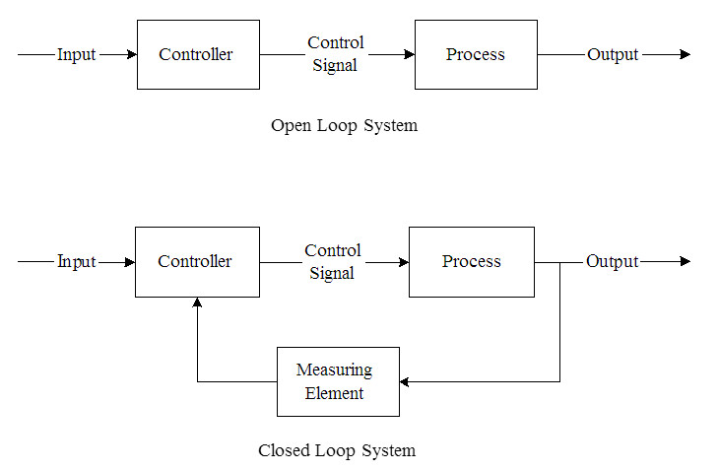

*Figure 5. Open loop and closed loop system*

We want to get accurate results from motor drive subsystem. Therefore, we will connect encoders to DC motors to make this system closed. Compared to the open loop system, the closed loop system offered:

* Significantly improved velocity smoothness;
* Reduced overall current consumption;
* Higher torque at lower velocities.

**4.1.3 Holonomic Control**

We chose holonomic control since its movement is better than the other options. It can move multiple direction (i.e. moving forward, backward, left, right and spinning around itself). It is based on three separately driven wheels placed on the robot body. The direction of the robot can be changed by varying the relative rate of rotation of its wheels. Therefore, it does not require an additional steering motion. Some example motions with varying speed of wheels are shown in Fig. 6.

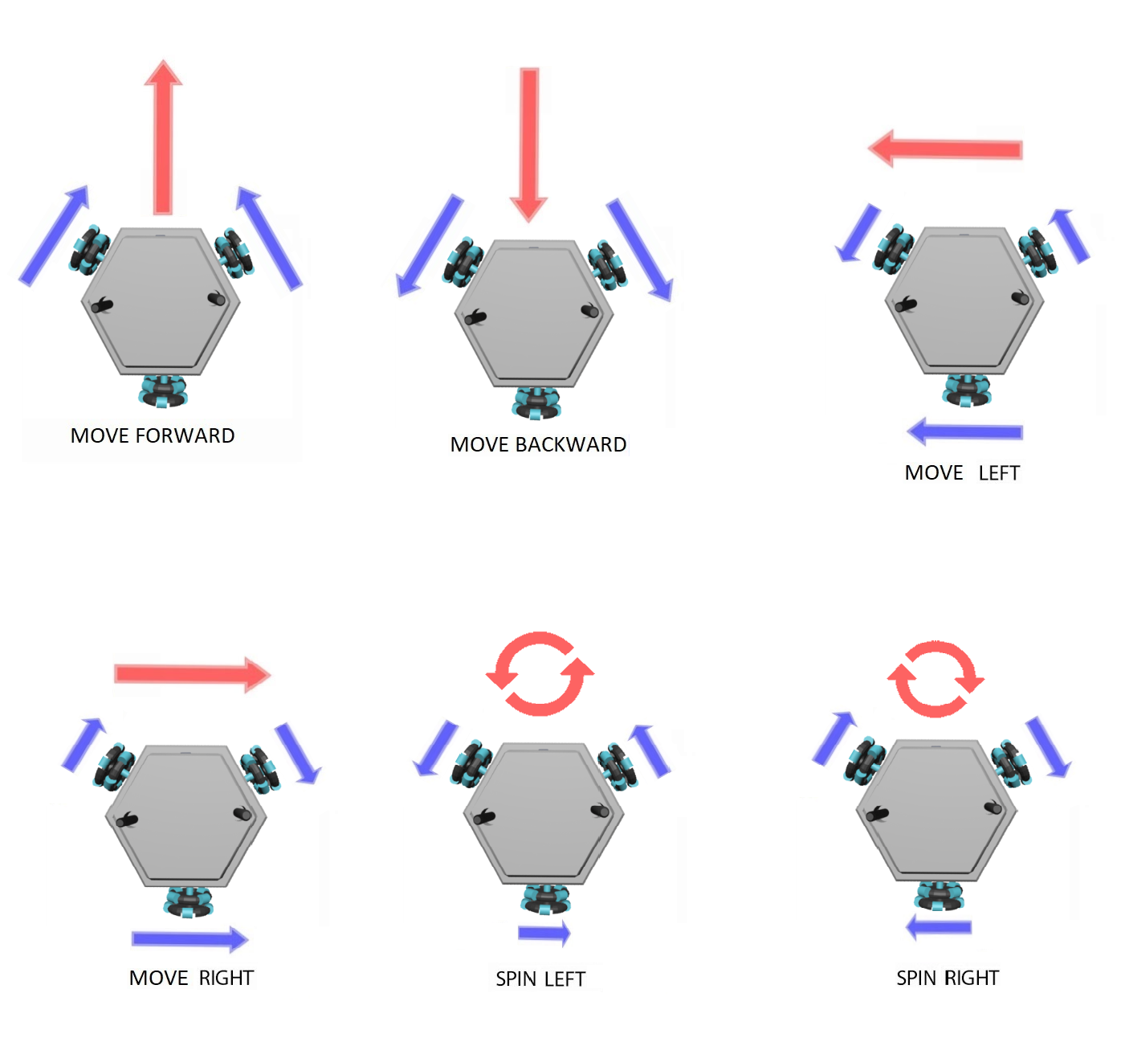

*Figure 6. Holonomic drive*

**4.1.4 DC Motor Drive Movements**

**i) Move Forward**

When user moves up the left analog of joystick, robot moves forward. For this operation, the two front DC motors should turn same speed and same rotation. This can be achieved with Arduino by setting the same PWM value to the both front motor pins. Note that different speeds can be obtained by changing the left analog position.



**ii) Move Backward**

When user moves down the left analog of joystick, robot moves backward. For this operation, the two front DC motors should turn same speed and same rotation. This can be achieved with Arduino by setting the same PWM value to the both front motor pins. Note that different speeds can be obtained by changing the left analog position.



**iii) Spin Right**

When user moves right the right analog of joystick, robot spins right. For this operation, all three DC motors should turn at the same rotation and same speed. Note that different speeds can be obtained by changing the right analog position. This can be achieved by changing the PWM values for the motor pins.



**iv. Spin Left**

When user moves left the left analog of joystick, robot spins left. For this operation, all three DC motors should turn at the same rotation and same speed. Note that different speeds can be obtained by changing the right analog position. This can be achieved by changing the PWM values for the motor pins.



**iv. Move Right**

When user press R1 button of joystick, robot moves right. For this operation, both front DC motors should rotate CCW direction and bottom DC motor should turn CW direction.

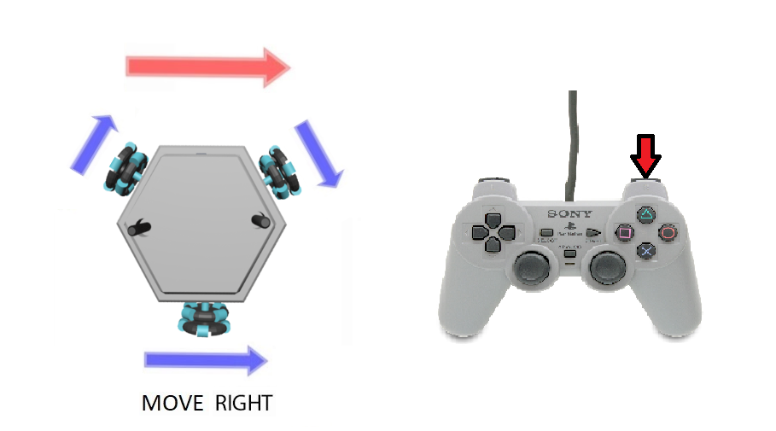

**iv. Move Left**

When user press L1 button of joystick, robot moves left. For this operation, both front DC motors should rotate CW direction and bottom DC motor should turn CCW direction.

-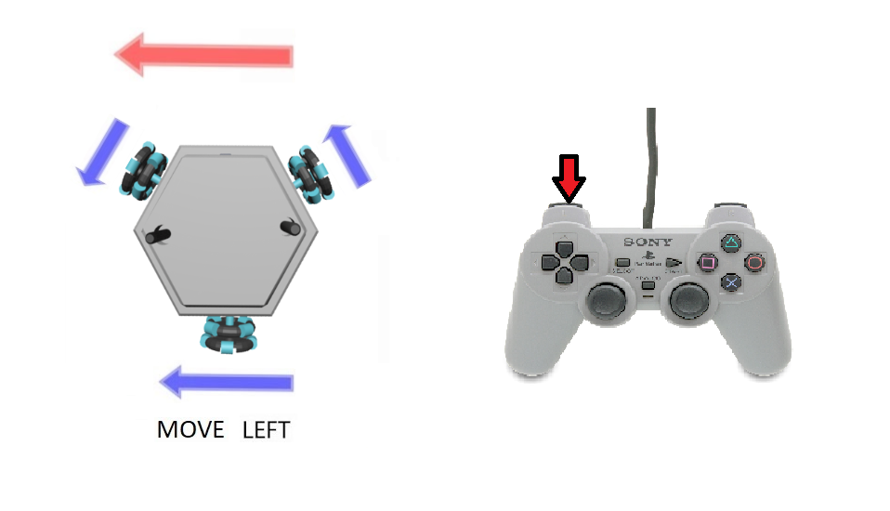

**4.2 Video transfer Subsystem**

We transfer the video as analog. It is the simplest and fastest way. Latency in analog transmission is less than other video transmission techniques(i.e. using image process technique ,using 3g internet) . We chose 5.8 GHz for video transmission due to its high transfer rate.It provides a better video stream than 2.4Ghz, 900 Mhz and 433 Mhz. This subsystem consists of transmitter and receiver systems. Also, we are using one 5.8g amplifier which improve our signal power from at the output of the transmitter as 27dBm to 32 dBm.

i. Transmitter:

We used a 600mw 5.8 GHz transmitter to transmit the video coming from a mini camera(Eachine TS5828S 40CH 5.8G 600MW) as shown in Fig. 4. It provides a high maximum range using its stock antenna. 



*Figure 7. TS5828S and 600TVL mini camera*

ii. Receiver:



We used ROTG02 as a 5.8Ghz FPV receiver. Advantages:

→ Good signal reception

→ Dual antenna system

→ 150 reception channels (5645~5945 frequency range)

→ Low latency (around 100 ms)

→ It can be connected to a smartphone (OTG)

*Figure 8. Eachine ROTG02*

iii. Amplifier

Output power 2500mW / 32dBm. It provides a video transfer without interruption.

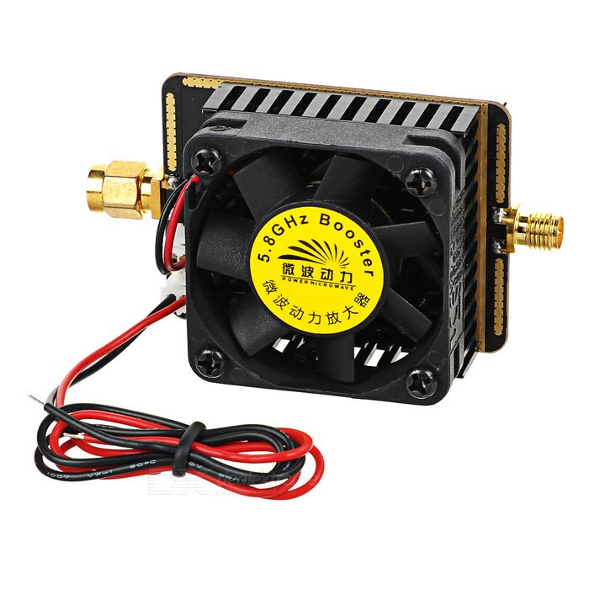

*Figure 9. Signal Booster*

**4.3 Command Transfer Subsystem**



*Figure 17. Command Transmitter system*

**i. Command Transmitter**

We built a command transmitter unit using PS1 joystick and NRF24L01 2.4Ghz transmitter as shown in Fig. 6. and Fig. 7. 



*Figure 10. Command Transmissitter unit Figure 11. Command Transmissitter unit with antenna*

We chose NRF24L01 because of some reasons.

* It is very cheap.
* Compatible with high gain antennas and 2.4ghz antennas are also very cheap.
* Transmitter output power is 20dBm.
* It has easy to use libraries and adjustable settings by many MCU and compatible with them.
* It has safety communication. It can use upon 5-byte configurable network address to communicate just in a specific network branch.
* It is easy to power-up. There is no need for additional power supply, we connected NRF modules directly to the Arduino to be energized.



*Figure 12. NRF24L01*

In our system, we use 15dBi 2.4Ghz linear antenna as shown in Figure X.



*Figure 13: 2.4ghz linear antenna*

These NRF transceiver modules can be communicated between them as reciprocal but in our system we set one NRF module as transmitter and other as receiver. The transmitter sends datas continuously regardless of acknowledge from receiver. We can use upon 32-bytes payload, but in our system we set it 1-byte because it’s enough for us. The power of NRF24L01 is around 100 mW and 20dBm and moreover, there is an antenna improvement that has been done which adds gain as 15 dBi. The communication protocol of NRF24L01 as follows.



*Figure 14. Communication protocol of NRF24L01*

**Preamble:** Shows beginning of a packet.

**Address:** Shows the network pipe address. This address is used by both transmitter and receiver to communicate just with each other.

**Packet Control:**  Section for related settings.

**Payload:** Sending data is stored inside. For our case it’s 1 byte.

**CRC:** Cyclic redundancy check for error detection. This error detection technique is based on checking the payload value by its CRC value. CRC value is generated by some arithmetic operations with the payload so that receiver can look at the payload and CRC value in order to find out if there is an error.

We connected PS1 joystick and NRF24L01 to Arduino UNO. Arduino senses the analog buttons and normal buttons of PS1 joystick repeatedly and read these datas. Then, send those datas by NRF transmitter module. We have resolution-255 for analog values.

**ii. Command Receiver**

We used NRF24L01 module to receive command datas sent by transmitter. We connected 15dBi 2.4Ghz linear antenna to it to increase its maximum range. It is not sending ACK to the transmitter back so that it is read-only. The receiver and transmitter share the same network address and share the same settings such as payload size, CRC size and data rate. After receiving the data, this module transfers the the datas to the microcontroller to process.

**4.4. Technical Specifications of Shooting Subsystem**

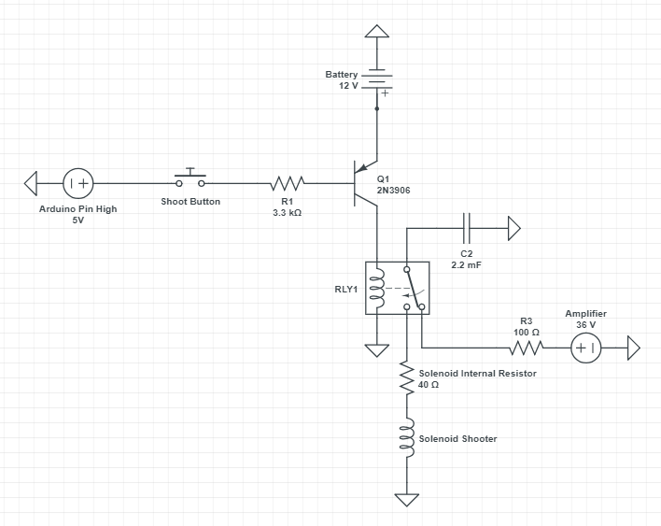

*Figure 15: Overall design scheme of shooting system*

After the researches, we decided to use solenoid push and pull actuator as our shooting system. It is much more simple than a mechanical spring system and it’s mainly related with our area.

We have a 24V solenoid actuator but we can use with higher voltage since our shooting operation is impulsive ( at the level of ms). According to the tests we made, operation with 12V (it is our source voltage coming from accumulator) is not powerful enough. Therefore, we prefer using DC-DC up converter to 36V and a 2200 uF capacitor parallelly connected to the solenoid.

We use a BJT ( Its base is connected to the digital output of the arduino mega) as the switching element and a SPDT relay which can switch between two different circuits. By switching the relay we are recharging capacitor onto the solenoid and after that the relay switch to the first circuit which charges the capacitor. Hence we are provided to get 36 volts to feed the solenoid without drawing too much current from battery.

**4.5 Technical Specifications of Power Supply Subsystem**

*Figure 16: Overall power supply subsystem scheme*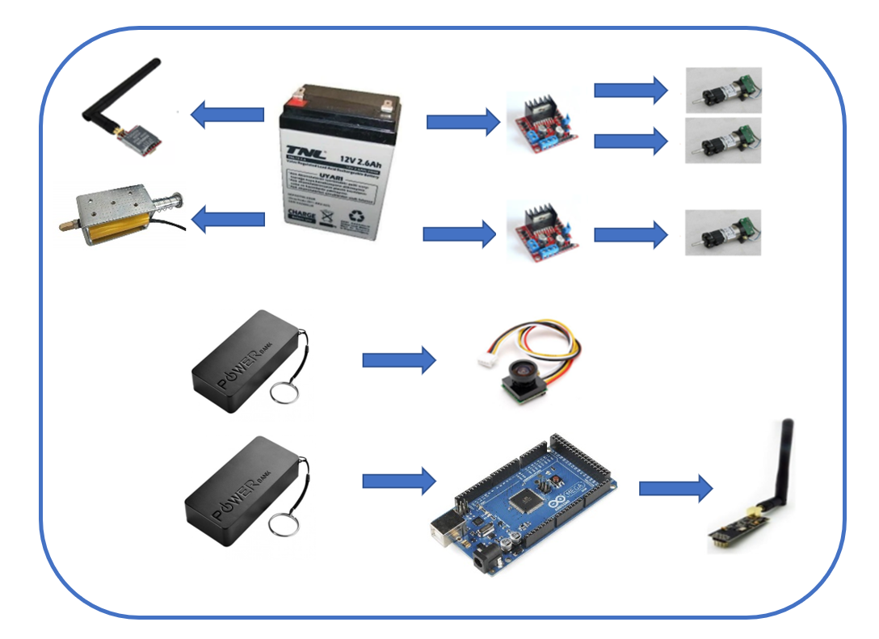

For power supply subsystem, we use one 12V (2.8Ah) accumulator battery and two power-banks. Accumulator battery supplies power for three DC motors, solenoid shooting subsystem and video transmitter. Power-banks are used for Arduino Mega and camera. That’s because motors, solenoid and video transmitter work with 12V whereas camera and Arduino Mega work with 5V DC. In addition, Arduino Uno is used to supply power for command transmitter at the controller (player/operator) side and Arduino Mega is used at the command receiver at the robot side. Therefore, NRF24L01 modules are directly connected to Arduinos. The overall power supply scheme is shown in Figure 16.

**5. System and Subsystem Modifications with Justifications**

**5.1 Modifications on Video Transfer Subsystem**

There is no major modification on the video transfer subsystem, but we implement a 5.8g amplifier. With the amplifier we improved our signal power from at the output of the transmitter as 27dBm to 32 dBm. Our video transmission was enough, but by doing it we can provide better transmission.

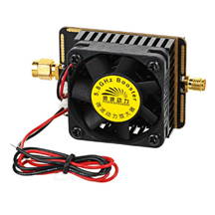

**5.2 Modifications on Movement Subsystem**

The modification on the design of the movement system can be considered as major modification. We changed the wheel system and decided to use omni-wheels rather than differential wheels. The reason of that modification is obtaining smoother movement and more aesthetic. Our differential wheels cannot move cross directly. Therefore, we used omni wheels which can provide movement to every direction.

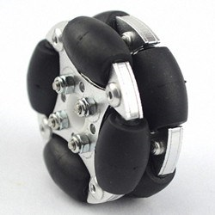

Figure 18: Omni wheel

**5.3 Modifications on Shooting Subsystem**

The modification on the design of the shooting system can be considered as major modification. We had multi options for shooting system and we did lots of researches for deciding. After comparisons which can be seen at the table, we decided to use solenoidal shooting system.

|  |  |  |  |
| --- | --- | --- | --- |
| **Properties** | **Spring** | **Pneumatic** | **Solenoid** |
| **Shooting Power** | **+** | **-** | **+** |
| **Weight** | **-** | **-** | **+** |
| **Space Required** | **-** | **-** | **+** |
| **Time between Shots** | **-** | **+** | **+** |
| **Safety** | **+** | **+** | **-** |
| **Simplicity** | **-** | **+** | **+** |
| **Number of Shots** | **+** | **-** | **+** |
| **Cost** | **+** | **+** | **+** |

Figure 19: Table of comparison

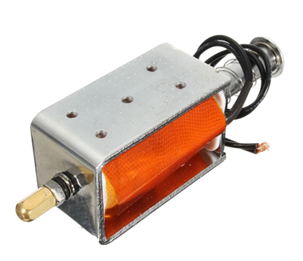

Figure 20: Solenoidal shooting system

**6.Compatibility of Subsystems**

In this project, we have five sub-systems, they are listed below:

→ Video Transfer

→ Command Transfer

→ Motor Drive

→ Shooting

→ Power Supply

The power supply subsystem energizes other subsystems and provide our robot DC power. All the elements of the power subsystem successfully fit the corresponding element that needs to be supplied. We paired them by considering their operation voltage and current values. The reason behind usage of accumulator battery is our budget constraint which is limited by 200 Dollars. We designed all the other parts by taking into account the extra mass coming from the accumulator battery. It would be more practical to use a Li-Po battery otherwise.

The compatibility of remaining four subsystems is not a matter of concern because they are all processing in different paths and they use different signal interfaces. We designed them such that their different operation states do not affect each other negatively. To be more precise, our video transfer subsystem operates at 5.8 GHz analog RF signal transmission while the command transfer is designed so that it uses digital signal at 2.4 GHz. The advantage of this design considerations is that a malfunction occuring in a unit does not ruin other parts.

**7. Design requirements**

**i) Analog Video Transfer Subsystem**

This subsystem requires an instantaneous vision from the camera on-board the robot. There are different types of solutions here, but we have chosen to send the FPV camera output just as it is. We did not include any image processing technique here or any other process on the image because they result in a considerable latency between the transmitter and receiver units.

**ii) Command Transfer Subsystem**

Command transfer subsystem is supposed to have all the functions that robot movements require. These movements include DC motor motion and action of the shooting system. Since the control unit has both the monitoring of the instantaneous video and transmitter part of the command control, this subsystem needs to be able to reach at least 30-meters range for indoor usage.

**iii) Motor Drive Subsystem**

This subsystem is required to have enough power and accuracy to move the robot as desired.

**iv) Shooting Subsystem**

Shooting system is required to have a stable mechanism so that every shoot has enough power to hit the ball in the desired direction to score.

**8. Test Results and Future Test Plans**

We tested our communication modules ( both video transmission and command transfer) in both closed and open regions.

Video Transmission: 300 m outdoor and 44 m indoor.

Command Transfer: 450 m outdoor and 60 m outdoor.

Also we tested our solenoid shooting system. It worked properly with 35 V while it is not powerful enough with 12 V.

**9. Cost And Power Analysis**

The parts of our robots are mainly supplied from China and Hong-Kong via some e-commerce websites. Our whole design at the end costs $162 so that this robot can be reproduced within that amount of budget.

|  |  |  |  |
| --- | --- | --- | --- |
| **Product** | **Pieces** | **Unit Price($)** | **Total Price($)** |
| nrf24l01+ | 2 | 1.78 | 3.56 |
| TS5828s | 1 | 7.70 | 7.70 |
| Camera | 1 | 6.27 | 6.27 |
| Video Receiver | 1 | 21.99 | 21.99 |
| Arduino Uno | 1 | 3.21 | 3.21 |
| Arduino Mega | 1 | 5.95 | 5.95 |
| Joystick | 1 | 2.84 | 2.84 |
| 15dBi antenna | 2 | 2.24 | 4.48 |
| 5.8g Amplifier | 1 | 20 | 20 |
| 12V Battery | 1 | 9.55 | 9.55 |
| Powerbank | 2 | 4.75 | 9.50 |
| DC motor | 3 | 8 | 24 |
| L298n | 2 | 1.43 | 2.86 |
| Omni wheel | 3 | 5.42 | 16.27 |
| Solenoid | 1 | 13.5 | 13.5 |
| Connection equipments and body | 1 | 10 | 10 |
| **TOTAL** | **24 pcs** |  | **162** |

*Table 2. Costs of parts in Helen-V*

**Links for Products**

nrf24l01 = <https://bit.ly/2Sl34Xk>

TS5828s = <https://bit.ly/2QOGyJS>

Camera = <https://bit.ly/2QNpZhs>

Video receiver = <https://bit.ly/2ENhqwI>

Arduino Uno = <https://bit.ly/2Sl35eb>

Arduino Mega = <https://bit.ly/2NNXAD5>

Joystick = <https://bit.ly/2Sl3eyf>

Antenna = <https://bit.ly/2EPMls2>

Signal Amplifier = <https://bit.ly/2IYHOXj>

Battery = <https://bit.ly/2Cxq9kr>

Solenid = <https://bit.ly/2SKavXG>

Powerbank = <https://bit.ly/2BCGgez>

DC Motor = Gözeler Elektronik, Konya Sokak, Ulus, Ankara

Motor driver = <https://bit.ly/2EOb1Rf>

Omni Wheel = <https://bit.ly/2UpvwIO>

Total Power: 26 W

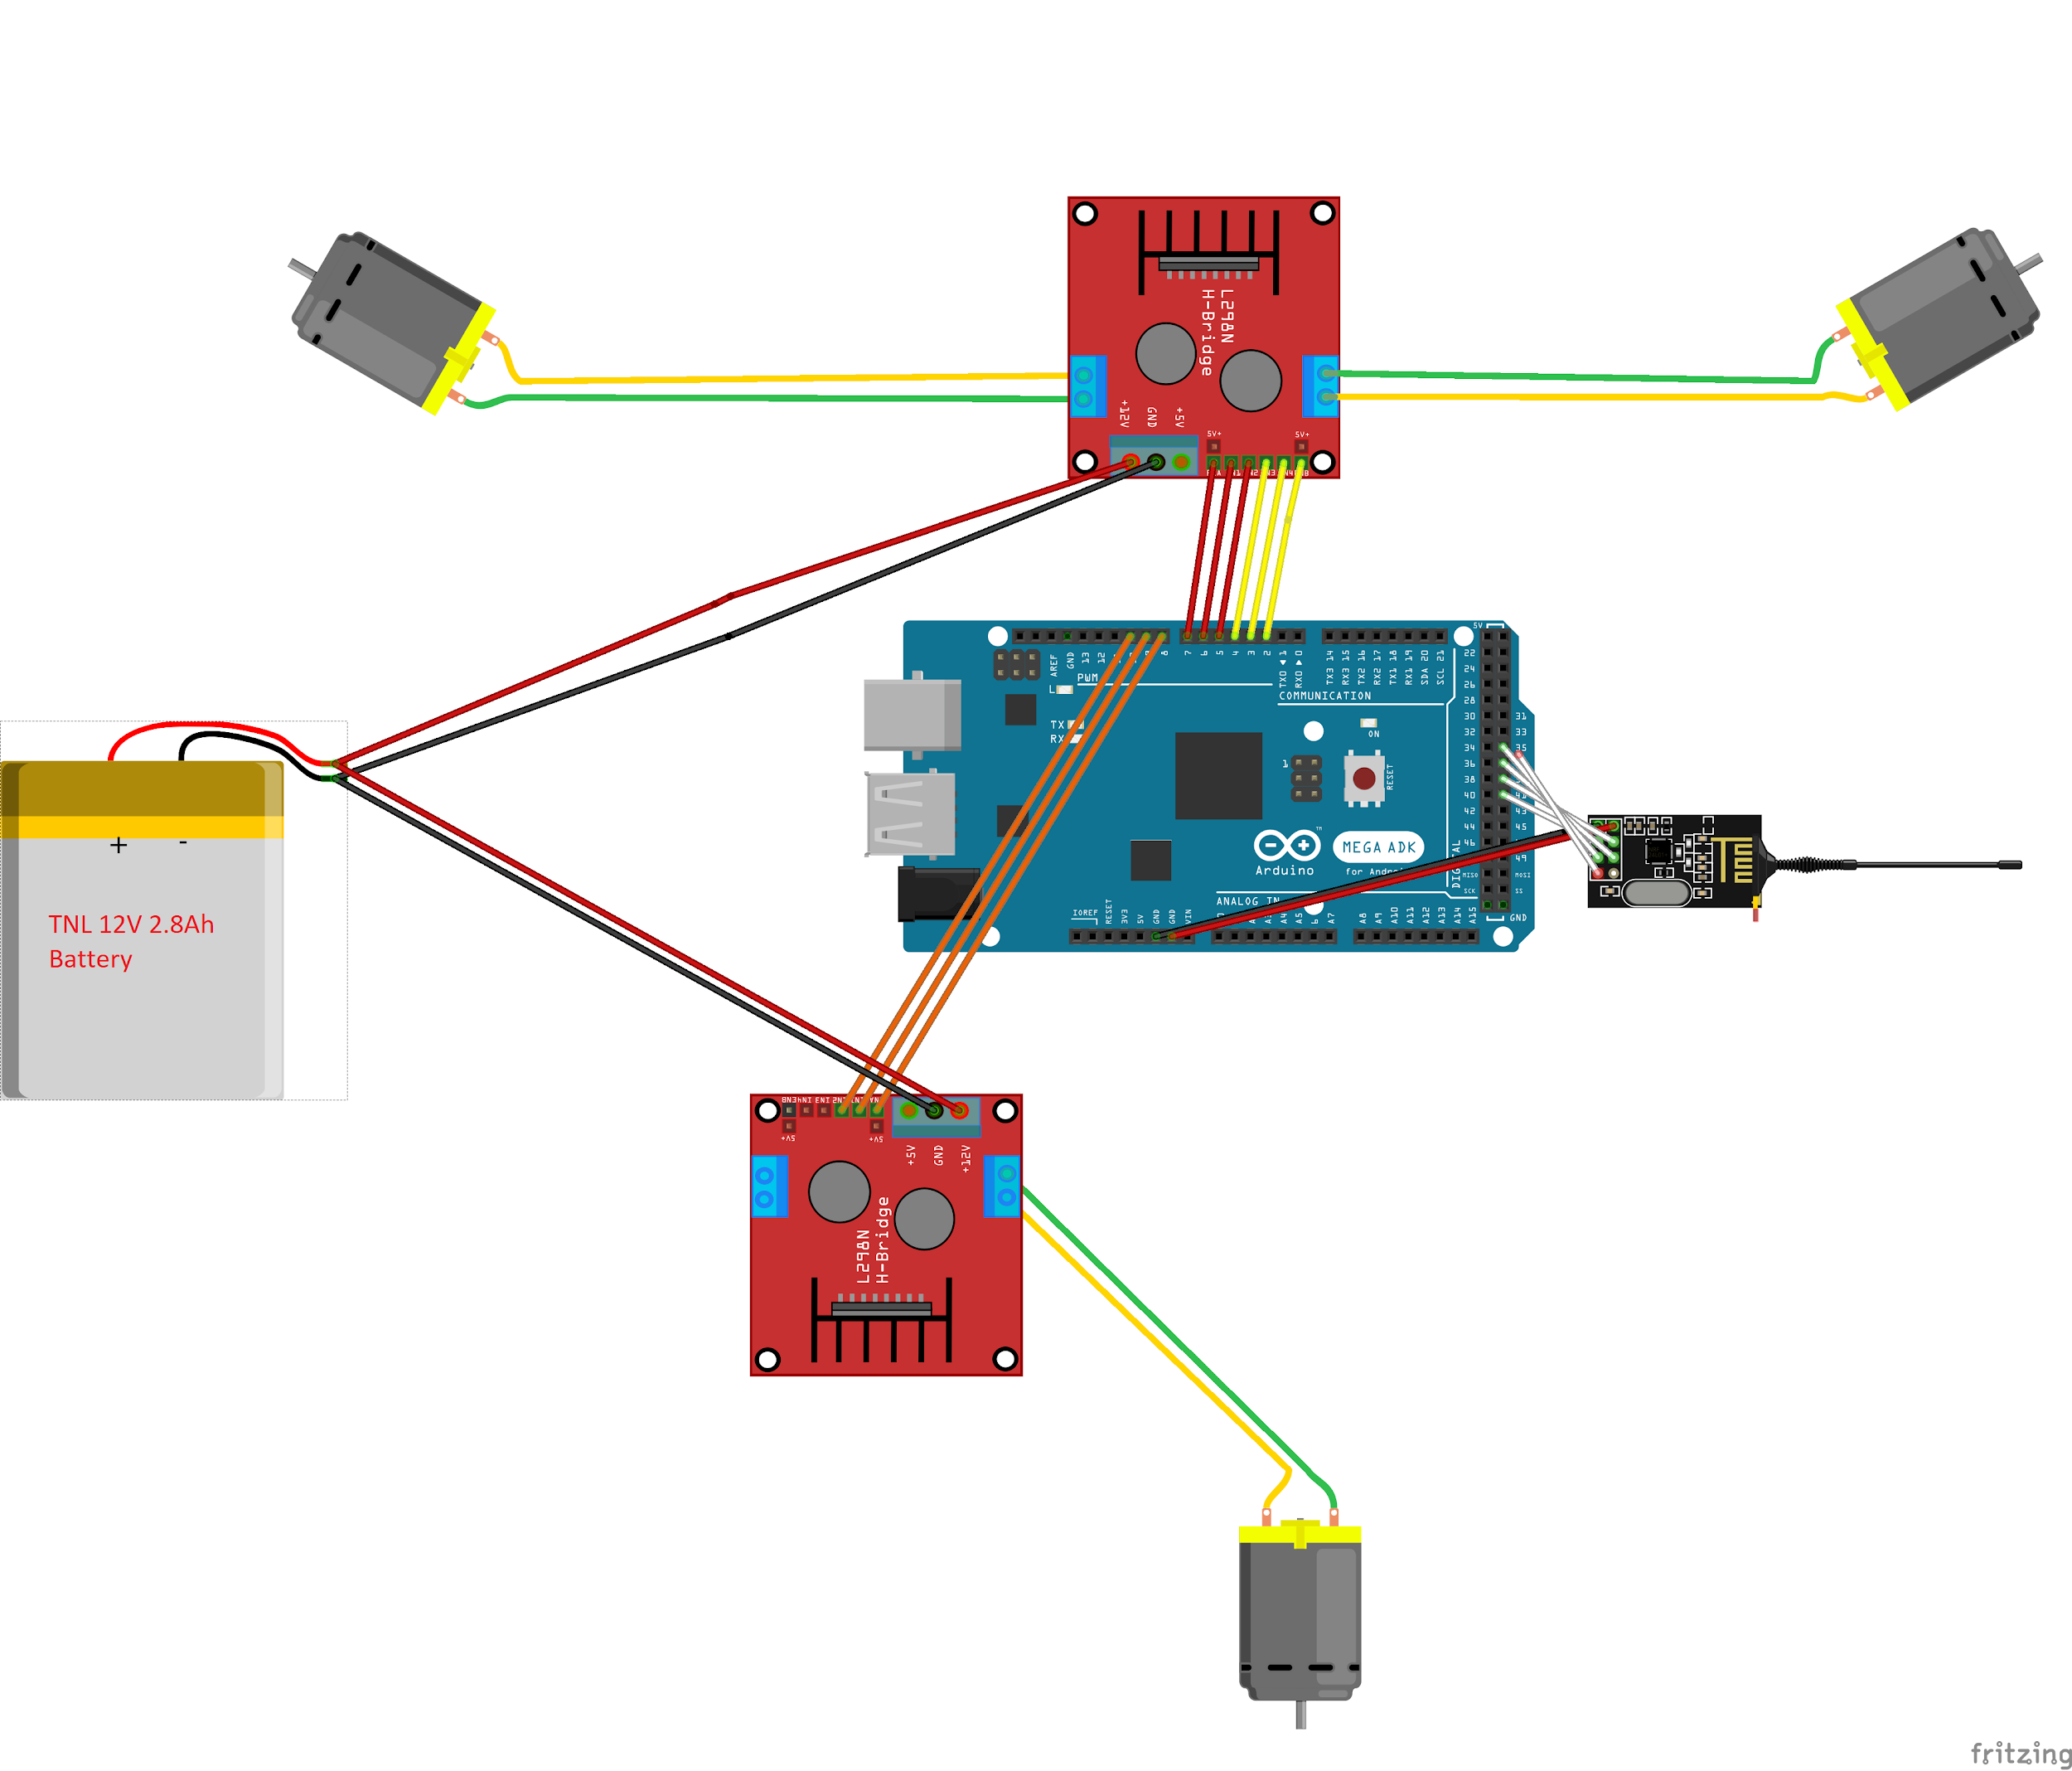

*Figure 20. Command Receiver and motor drive system*

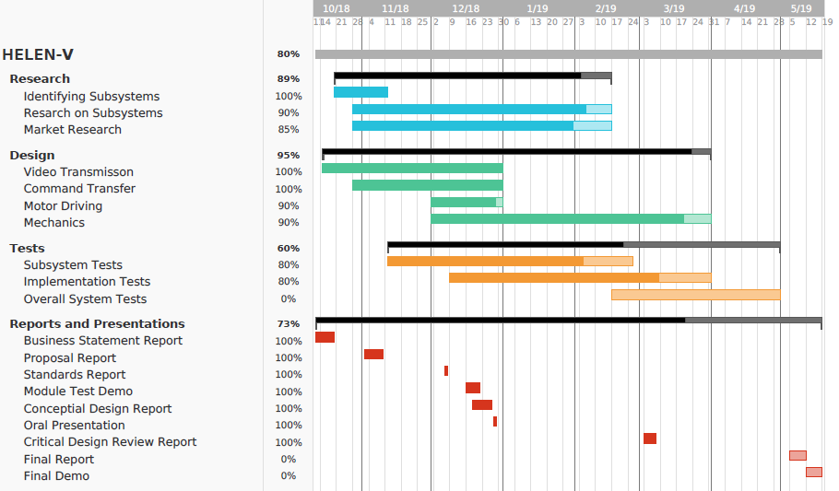

*Figure 20. Gantt Chart*

***10.CONCLUSION***

Our product “Helen V” is designed for a specific project which is named as “designing and constructing one of the two teleoperated robots trying to shoot and score in opponent’s goal”. In this report, we have introduced the final steps of our design journey.

As mentioned previous reports, we know our responsibilities and requirements for the design procedure. We made enough progress in the first semester, in this semester we finalized our product by choosing proper components and improving. We made our shooting system and movement system definite with respect to lots of researches and comparisons. We tried to implement the most efficient components to our products. Also, we improved our working video transmission system and aimed to obtain one beyond the requirements. In addition, we focused on appearance of our “Helen V”. We did our best while designing our product and locating the components to create an eye-pleasing appearance.

Troy Tech will deliver a proper design product which is compatible with the requirements, within a short timeframe and economic budget. Our main desire as a company is to provide unique and affordable products with significant functions, durability and performance. In this project, we present a perfect working robot includes unique design marks and inevitable labor.

**11.References**

Hamby, C. (2013, November 26). Top Benefits And Top Disadvantages To Using A 5.8 GHz Frequency? Retrieved from <https://www.avalan.com/blog/bid/354696/Top-Benefits-And-TopDisadvantages-To-Using-A-5-8-GHz-Frequency>

Perlman, A. (2016, August 20). Everything You Need to Know About FPV Flying. Retrieved from https://uavcoach.com/everything-need-know-fpv-flying/ User’s Basic Guide to Radio

Control Systems. (n.d.). Retrieved from <http://www.rcmodelswiz.co.uk/rc-guides/electric-rc-models-guide/users-basic-guide-to-radiocontrol-systems/>

Wheel Control Theory. (n.d.). Retrieved from http://www.robotplatform.com/knowledge/Classification_of_Robots/wheel_control_theory.html

**Appendix: Technical Drawing of The Robot**

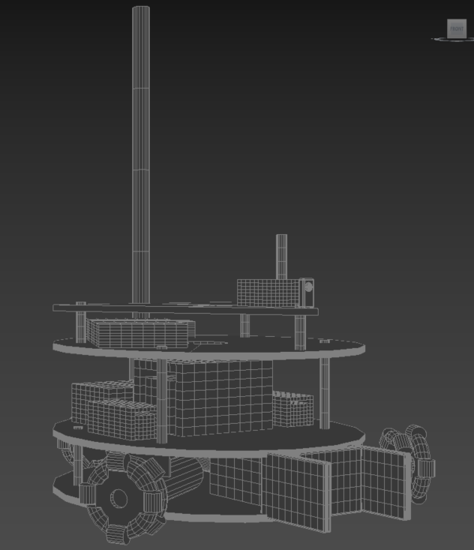

**Figure 20: Front view.**

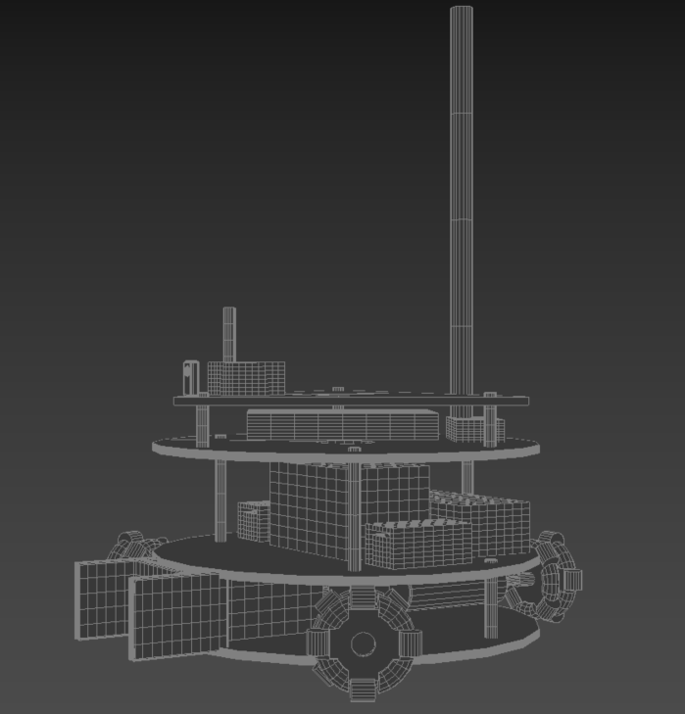

**Figure 21: Right view.**

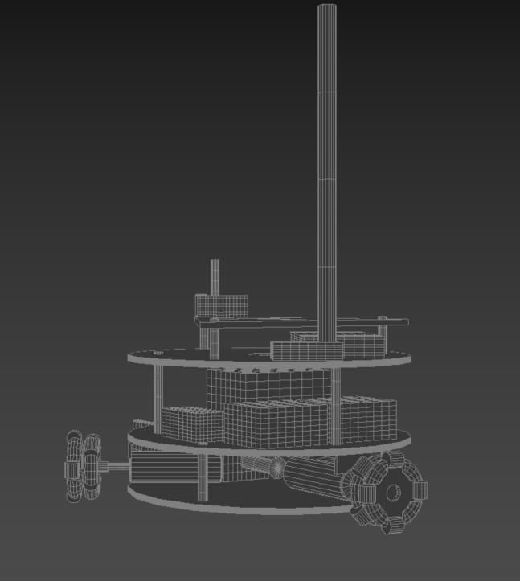

**Figure 22: Left view.**

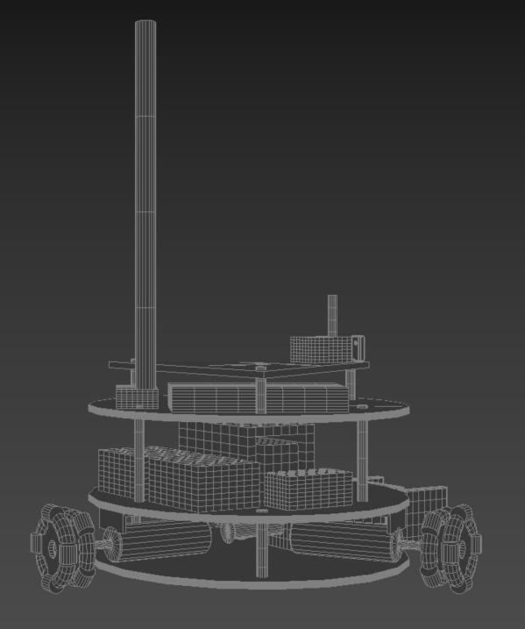

**Figure 23:Back view.**

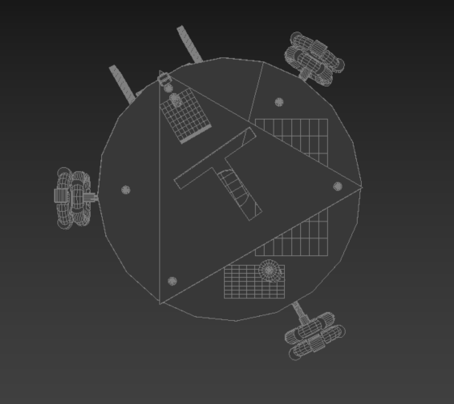

**Figure 24 :Top view.**

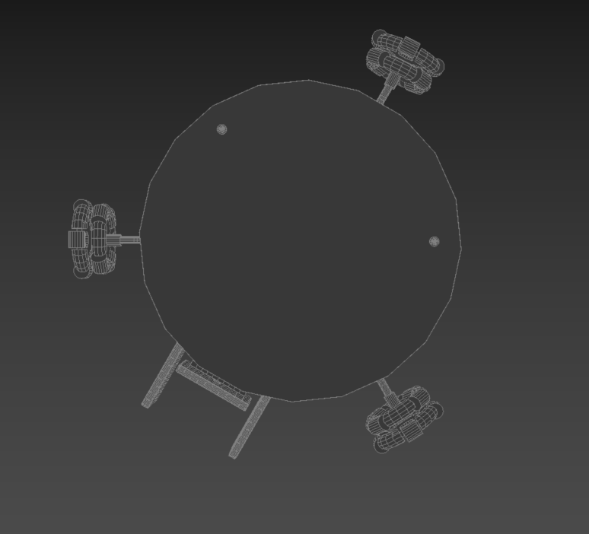

**Figure 24 :Bottom view.**

